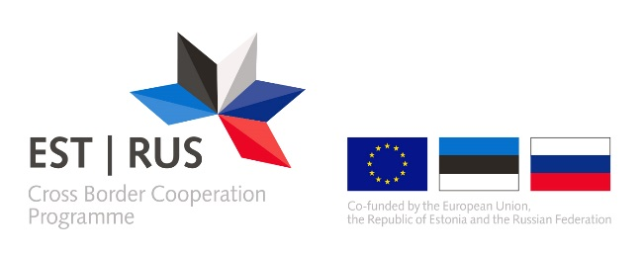

ANNEX 7

DECLARATION OF APPLYING STATE AID / DE MINIMIS AID

Activity | Total cost of the activity (inc VAT) | Eligible cost of the activity | Aid intensity (%) | Aid amount | State aid / de minimis aid / non-economic activity
No 1
No 2
No 3
No …

This declaration is only applicable to the applicants and/or partners from Estonia.
Please indicate which of the following aid regulations you apply: 1) State aid Regulation (EU) No 651/2014 (article 14, 53, 55 or 56); 2) de minimis aid Regulation (EU) No 1407/2013; 3) de minimis aid Regulation (EU) No 717/2014. If the activity is marked as non-economic please justify briefly why this activity is not State aid relevant according to the points 2-7 of the State aid guidelines for the large infrastructure projects of the Estonia-Russia cross border cooperation programme 2014-2020.

