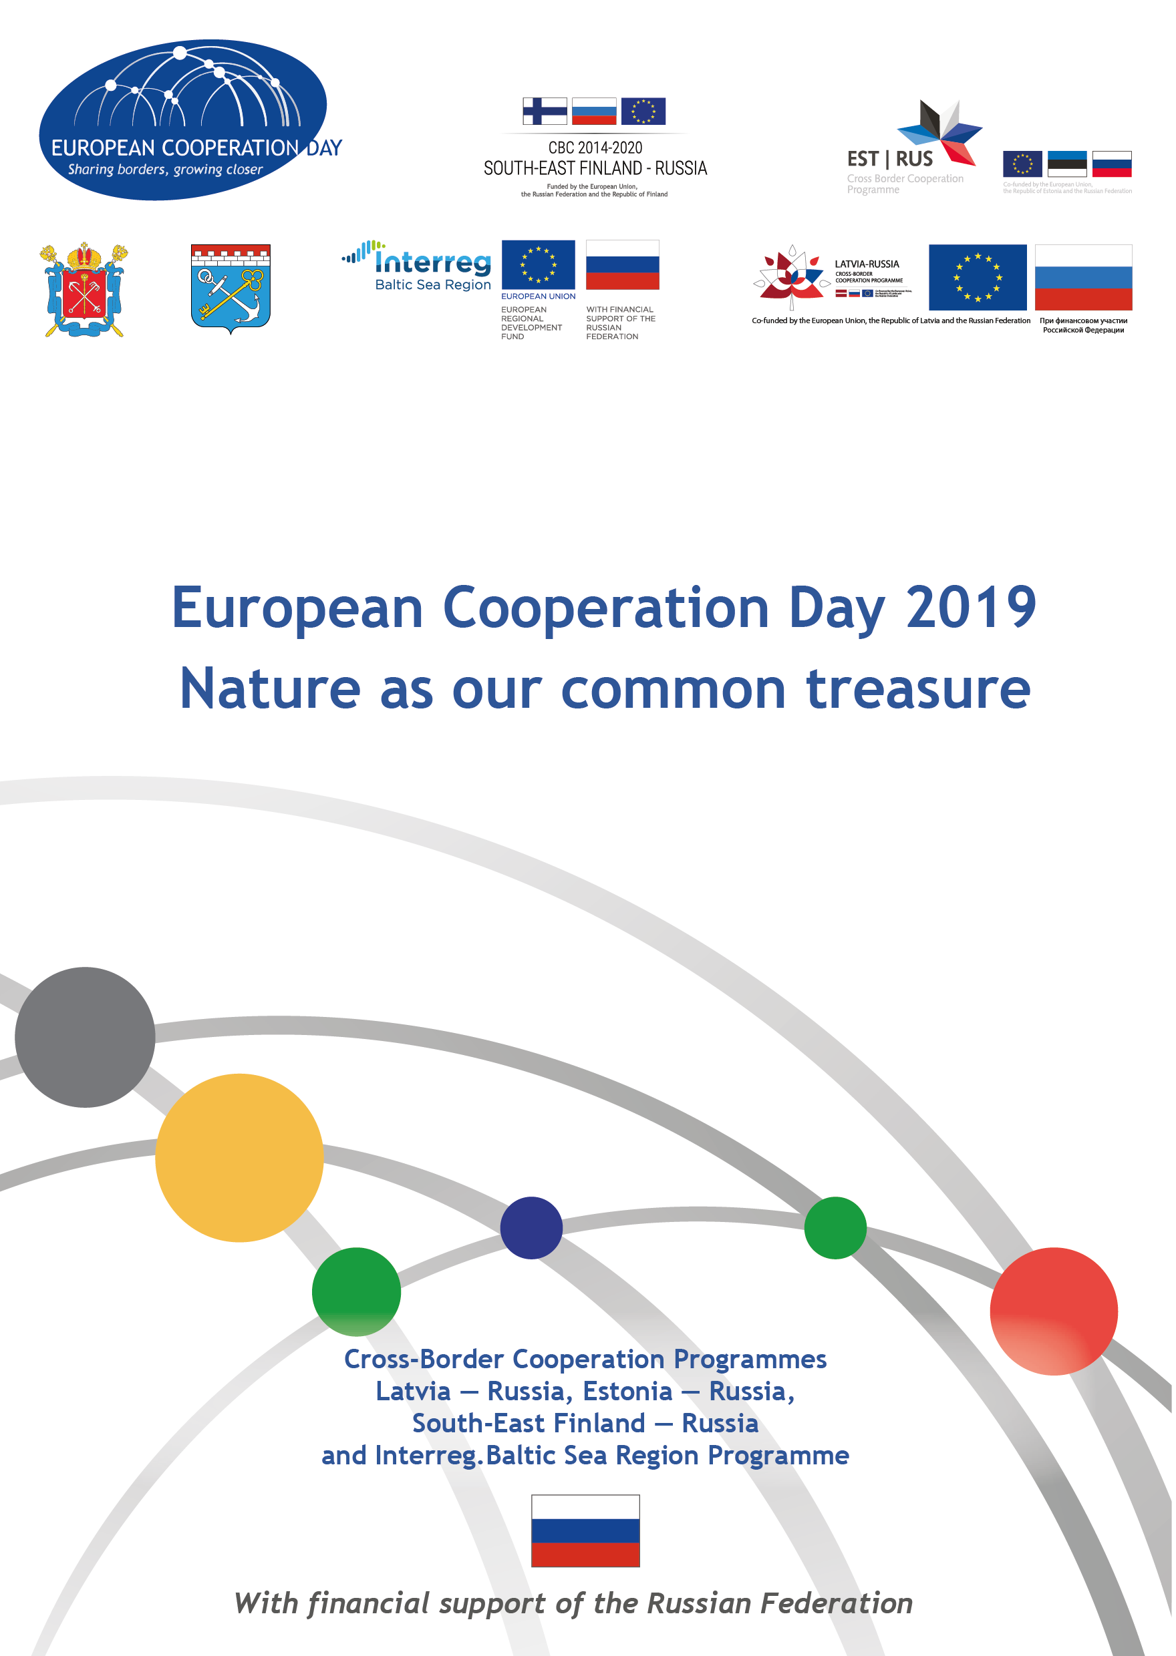

Оглавление
Agenda of the EC Day 2019 4
Latvia — Russia Cross-Border Cooperation Programme 2014—2020 6
Estonia — Russia Cross Border Cooperation Programme 2014—2020 8
South-East Finland — Russia Cross Border Cooperation Programme 2014-2020 10
The Interreg Baltic Sea Region Programme 2014-2020 12
Projects
Promotion of water resource sustainability for tourism and attractiveness of CBC of Rēzekne & Ostrov 14
Pure Water for Programme Regions 15
Improvement of environmental management through joint actions in Programme’s cross-border regions 16
HAZardous chemicals in the eastern Gulf of Finland — concentrations and impact assessment 17
Restocking of European eel as a measure of recovery of endangered species and preservation of natural diversity 18
Water Managment of the Narva River: harmonizaion and sustention 19
CoExist — Towards sustainable coexistence of seals and humans 20
GET READY — Getting Ready for the Cross-Border Challenges: Capacity Building in Sustainable Shore Use 21
One Drop — A Novel Mobile Water Purification Plant 22
BSR WATER — Platform on Integrated Water Cooperation 23
MANURE STANDARDS — Advanced manure standards for sustainable nutrient management and reduced emissions 24
WATERDRIVE — Water driven rural development in the Baltic Sea Region 25
Notes 26

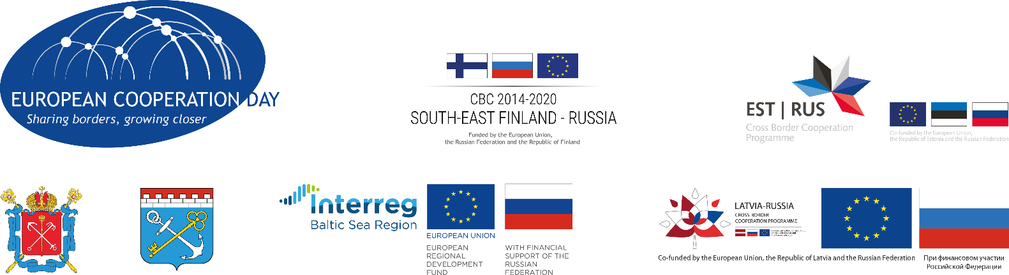
Agenda of the EC Day 2019
Nature as our common treasure
Date and time:  Venue: | 25th September (Wednesday), 10:00 – 15:00  Information and Education Center of the St. Petersburg Vodokanal,  Russia, St. Petersburg, Shpalernaya str., 56.
09:00 — 10:00 | Welcome coffee
10:00 — 10:40 | Event opening – conference hall  - Introduction of partners and organizers  - Welcome words from representatives of local and regional authorities and the EU Delegation to Russia (tbc)  - Welcome words of representatives of Latvia-Russia, Estonia-Russia, South-East Finland – Russia CBC Programmes and Interreg Baltic Sea Region Programme  - Thematic quiz (introduction into cultural, geographical, nature and other specific features of border areas)  - Outline of activities
10:40 — 13:00 | For officials – guests of event:  - Guided tour to the “Museum of water” https://www.youtube.com/watch?v=gk_jI9L2rOo  - Introduction to the exhibition of 12 projects implemented within the framework of Latvia-Russia, Estonia-Russia, South-East Finland – Russia CBC Programmes and Interreg Baltic Sea Region Programmes  - Introduction to the activities of the Information and Education Center of the St. Petersburg Vodokanal  For school graduates and students:  - Introduction to the exhibition of 12 projects implemented within the framework of Latvia-Russia, Estonia-Russia, South-East Finland – Russia and Interreg Baltic Sea Region Programmes  - Brief interactive introduction on specifics of the Baltic sea region  - Brain storm on the existing synergies and new projects ideas for nature saving which can be proposed for implementation in the new programming period 2021-2027  - Preparation of the brief presentations by groups on the outcomes of the brainstorm
13:00 — 14:00 | Wrap-up of the event – conference hall  - Presentations of the ideas for the future programming period  - Voting for the ideas for ranging  - Summing up of the results
14:00 — 14:30 | Culinary journey  Introduction into culinary traditions of Baltic Sea countries.

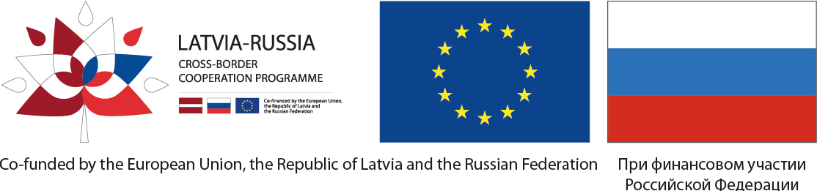
Latvia — Russia Cross-Border Cooperation Programme 2014—2020

Programme goal
The vision of the Programme is to reach the positive changes in entrepreneurship, environmental and cross-border mobility sectors.
The strategic goal is to support joint efforts for addressing cross-border development challenges and promote sustainable use of existing potential of the area across border between Latvia and Russia.

Programme area
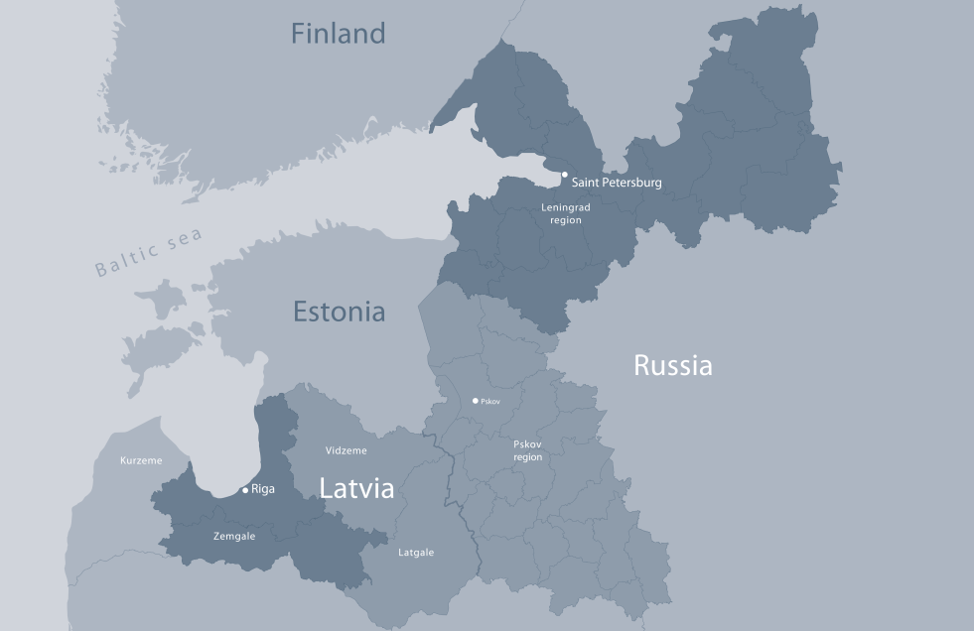
 | The Russian Federation  Core regions:  Pskov region  Adjoining area:  Leningrad region | The Republic of Latvia  Core regions:  Vidzeme, Latgale  Adjoining area:  Pieriga, Zemgale
Riga and Saint Petersburg are considered as major economic centres of the Programme area.

Programme Financing
Total budget: 27,08 MEUR, including co-financing
European Union: 15,87 MEUR
The Russian Federation: 7,93 MEUR
The Republic of Latvia: 0,99 MEUR

Thematic objectives (TOs)
TO 1. Business and SME development
TO 6. Environmental protection, climate change mitigation and adaptation
TO 10. Promotion of border management and border security, mobility and migration ******__management

Projects
Calls for proposals
As of September 2019, the Programme delivered 2 calls for proposals with 17 projects selected totaling 9,49 MEUR, including the Programme co-financing of 8,54 MEUR. 16 project have already started implementation of the planned activities.
Direct award projects
- The Programme includes 4 direct award projects with the total budget of 13,04 MEUR. These are
- “Improvement of the border crossing approach road Lavry – BCP “Brunishevo”
- “Preservation and promotion of the cultural and historical heritage in Latvia and Russia”
- “Pure water for programme regions”
- “Improvement of border crossing point Terehova-Burachki”
To find our more, head over to http://latruscbc.eu/projects/

Contacts
https://www.latruscbc.eu https://www.facebook.com/latruscbc/

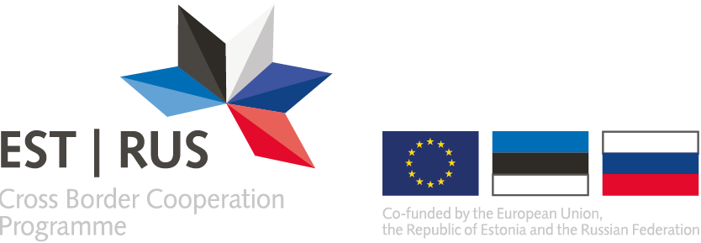
Estonia — Russia Cross Border Cooperation Programme 2014—2020

Programme goal
The Estonia-Russia Cross Border Cooperation Programme 2014-2020 aims to foster cross-border cooperation between the Republic of Estonia and the Russian Federation to promote socio-economic development.
Programme Area
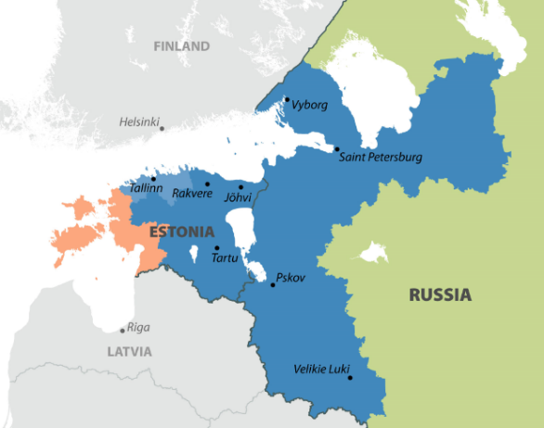
The Russian Federation
Core regions:
Saint-Petersburg,
Leningrad and Pskov regions

The Republic of Estonia
Core regions:
Kirde-Eesti, Lõuna-Eesti, Kesk-Eesti
Adjoining regions:
Põhja-Eesti

Programme Financing
Total budget: 34.2 mill. euro, including co-financing
European Union: 16.8 mill. Euro
The Russian Federation: 8.4 mill. Euro
The Republic of Estonia: 9 mill. euro

Thematic objectives (TO)
TO 1. Business and SME development.
TO 5. Support to local and regional good governance.
TO 6. Environmental protection, climate change mitigation and adaptation.

Projects
Calls for proposals
By September 2019 the Programme has held 2 Calls of proposals and the 3rd Call of proposals is planned for the beginning of the next year.
All together 26 projects were selected. The implementation of 18 contracted projects is in full speed. The total planned sum of grants is about 10 mill. euro.
Large infrastructure projects
4 large infrastructure projects have been contracted and the total sum of funding is 20.47 mill. euro.
- Improving of the Accessibility of the Remote Areas in the South-East Estonia and Pskov Region for Traditional Entrepreneurship and Sustainable Development;
- Economically and Environmentally Sustainable Lake Peipsi area 2;
- Development of the unique Narva-Ivangorod trans-border fortresses ensemble as a single cultural and tourist object. 2nd stage;
- Development of historical riverside protection area in Narva/Estonia and Ivangorod/Russia. 3rd stage
More information: https://www.estoniarussia.eu/publications/selected-and-supported-projects/

Contacts
https://www.estoniarussia.eu www.facebook.com/estoniarussia/
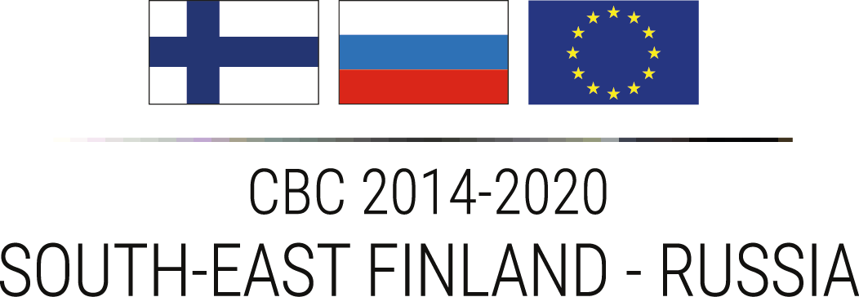

South-East Finland — Russia Cross Border Cooperation Programme 2014-2020

Programme goal
The Programme contributes to economic and social development, mitigate common challenges and promote mobility among actors of regional relevance to further improve cross-border cooperation and the sustainable prerequisites of the Programme area.
By funding Finnish-Russian joint projects, the Programme aims at solving challenges that note no geographical borders. Funded projects include for example culture-, tourism-, education-, and research cooperation, economic and social development, or actions that aim at preventing environmental disasters and mitigate climate change. Projects also contribute to sustainable development, mobility and safety at the land and sea borders.
Programme Regions
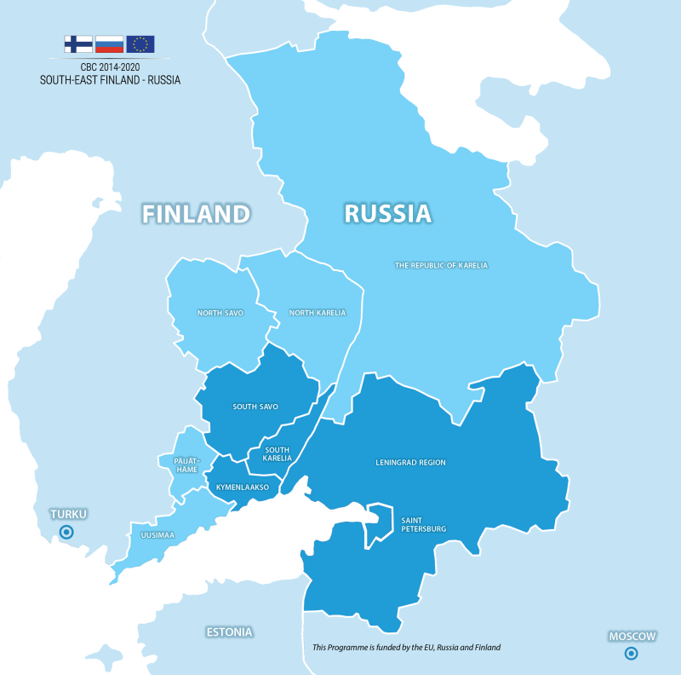
In Russia
- Core regions:
Leningrad region,
Saint-Petersburg.
- Adjoining regions and
major social, economic or
cultural centres:
Republic of Karelia,
The city of Moscow.
In Finland
- Core regions: South Karelia,
South-Savo and Kymenlaakso.
- Adjoining regions and
major social, economic
or cultural centres: Uusimaa,
Päijät-Häme, North-Savo,
North Karelia, the city of Turku.

Financial frame
Overall frame: € 77,5 Mio. from three financiers:
EU co-financing is € 36,1 Mio.
Co-financing from Russia is € 18,1 Mio.
Co-financing from Finland is € 23,3 Mio.

Thematic priorities
Business and SME development
Priority 1: Lively, active and competitive economy
Support to education, research, technological development and innovation
Priority 2: Innovative, skilled and well-educated area
Environmental protection, and climate change mitigation and adaptation
Priority 3: Attractive, clean environment and region
Promotion of border management and border security, mobility and migration management
Priority 4. Well connected region

Projects
By September 2019, 36 standard projects with total funding of € 31 Mio and 9 large infrastructure projects with total funding of € 38 Mio have started implementation. The total Programme grants for projects are expected to be ca. € 70,3 Mio. For more information, please see https://www.sefrcbc.fi/information-service/.

Contacts
https://www.sefrcbc.fi/ https://www.facebook.com/cbcprogramme/

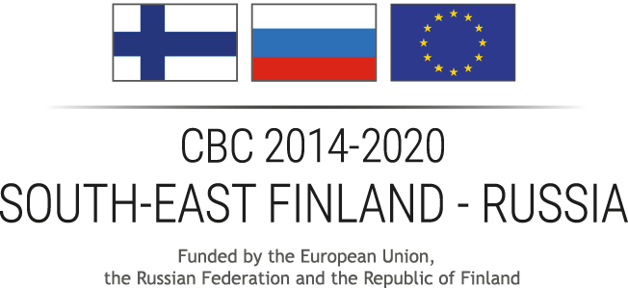
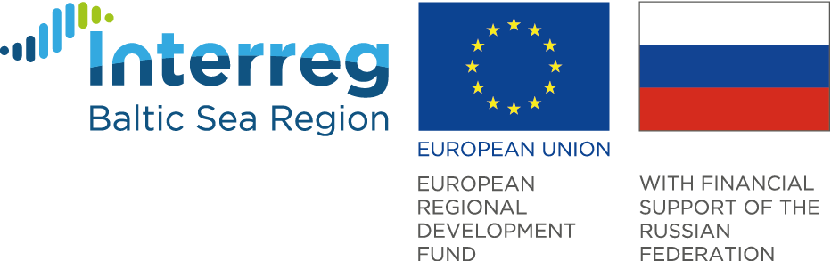

The Interreg Baltic Sea Region Programme 2014-2020

Objective of the Programme
The Interreg Baltic Sea Region Programme for 2014 to 2020 supports integrated territorial development and cooperation for a more innovative, better accessible and sustainable Baltic Sea region. Partners from ten countries around the Baltic Sea work together in transnational projects on common key challenges and opportunities.
Projects bring together administrations of cities and regions, universities, NGOs and businesses. They build a common pool of competencies to boost regional economies and use natural resources wisely. At the same time, they build personal relations that create liaisons across the borders.
Programme Countries
EU member states Denmark, Estonia, Finland, Latvia, Lithuania, Poland, Sweden and the northern parts of Germany as well as partner countries Norway and the northwest regions of Russia.
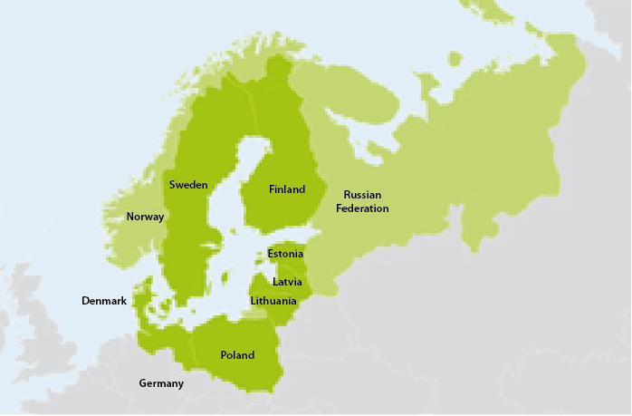

Financial frame
Overall frame:€ 277.9 Mio. from:
European Regional Development Fund: € 263.8 Mio.
Norwegian national funding: € 5.3 Mio.
European Neighbourhood Instrument: € 4.4 Mio.
Russian national funding: € 4.4 Mio.

Thematic priorities
Priority 1: Capacity for innovation
Priority 2: Efficient management of natural resources
Priority 3: Sustainable transport
Priority 4: Institutional capacity for macro-regional cooperation

Projects
By September 2019, 123 projects in priorities 1-3 with total Programme co-financing of € 255.6 Mio have started implementation. Russian partners have taken part in more than 40 projects, with total Programme co-financing of € 7.2 Mio to them. For more information, please see https://projects.interreg-baltic.eu/.

Contacts
https://www.interreg-baltic.eu

Promotion of water resource sustainability
for tourism and attractiveness of CBC of Rēzekne & Ostrov
Thematic objective
Environmental protection, climate change mitigation and adaptation
Beneficiaries
- Rēzekne City Council
- Administration of Ostrov district
- Latvia University of Life Sciences
- Pskov State University
Budget  Total budget: 621 021.77 €  Programme co-financing: 558 919.59 € | Duration  24 months  1.06.2019 — 31.05.2021
Summary
The project will contribute to improvement of environmental condition and infrastructure of Rēzekne and Velikaya rivers, maintaining the balance of social, economic and environmental factors. To develop more accessible urban waterfronts the project will implement the following activities:
- Reconstruction of river bank: in Rēzekne city improvements though attractive design objects, landscaping elements, boating stations, walking paths and greenery along the river; in Ostrov city – focus on the central part of the river, developing the central part of the city, nearby objects of historic importance;
- Creation of BLUE PASSPORTS – extensive descriptions on both project sites, including new sustainable interactive waterfront tourism routes and attractions;
- Production of materials for eco-quests,
- Research “Preventing water body pollution and flooding” of 2 water basins in Rēzekne and Ostrov,
- Development of “Integrated resources management manual” to be integrated in two universities’ study programs;
- Trainings for regional tourism actors and stakeholders,
- Capacity building workshops for municipalities and scholars.
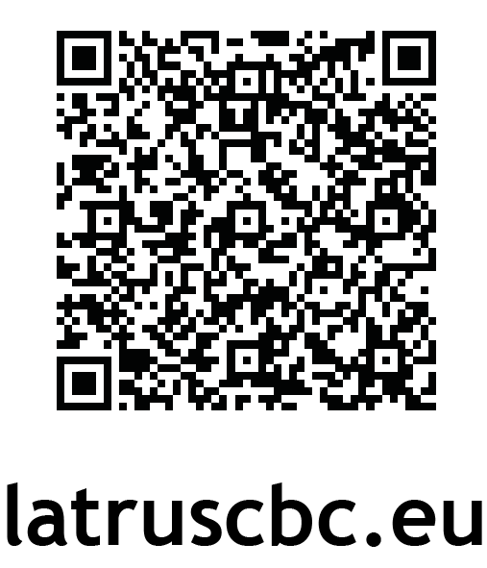
Contacts
Rēzekne City Council
dome@rezekne.lv
www.rezekne.lv

Pure Water for Programme Regions
Thematic objective
Environmental protection, climate change mitigation and adaptation
Beneficiaries
- Municipal Enterprise of Pskov city "Gorvodokanal"
- Latgale Planning Region
Budget  Total budget: 3 888 888.89 €  Programme co-financing: 3 500 000.00 € | Duration  24 months  01.06.2019 — 31.05.2021
Summary
“Pure water for programme regions” project contributes to higher quality of drinking water and raising the awareness of sustainable water consumption in Pskov region (Russia) and Latgale region (Latvia).
Currently, water intake in Pskov comes directly from local river Velikaya failing to meet national quality standards. Challenging purification process of this water leads to discharges into a joint basin of Peipsi Lake. The project partners are to implement a sustainable common solution to ensure high quality drinking water supply from the underground layers in Pskov.
Water treatment professionals will be trained to use recent technologies and solutions in water supply and wastewater treatment. Decision makers will be introduced to cutting-edge approaches for more focused and sustainable water management. Trainings will be supported by exchange trips to Latgale and Pskov.
The project will also focus on awareness raising among locals on both sides of the border (200K of inhabitants in Pskov and over 270K inhabitants in Latgale region) offering a variety of public campaigns:
- “Water Journey” and “Small Aquatic Creatures” interactive installations (Latgale region);
- “Day of Water” festival bringing locals better skills of responsible water management (Pskov);
- handy information will be provided on the most used water management document – monthly utility bills thus virtually reaching every family (Pskov).
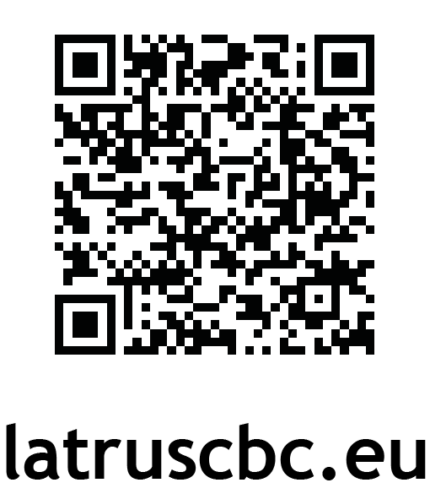
Contacts
Municipal Enterprise of Pskov city "Gorvodokanal"
office@vdkpskov.ru
www.vdkpskov.ru

Improvement of environmental management through
joint actions in Programme’s cross-border regions
Thematic objective
Environmental protection, climate change mitigation and adaptation
Beneficiaries
- Euregio “Pskov-Livonia” section Latvia
- Administration of the Pytalovsky district
- Administration of the Palkinsky district
- Administration of the Krasnogorodsky district
- Pskov section of the Euroregio "Pskov-Livonia"
- Administration of Vilaka municipality
- Administration of Balvi municipality
- Administration of the Viļāni municipality
- Administration of the Smiltene municipality
Budget  Total budget: 646 735.00 €  Programme co-financing: 582 061.50 € | Duration  24 months  01.08 2019 — 31.07.2021
Summary
7 solutions are reflected in 7 key activity areas of the project:
- prevention and localization of local wood and dry grass fires;
- spring floods prevention;
- fighting cow parsnip intervention;
- green minded behavior, illegal dumping liquidation and recycling;
- energy efficiency and use of alternative “green” energy;
- wise management of local water bodies;
- inter-municipal cooperation for prevention and response to emergency situations.
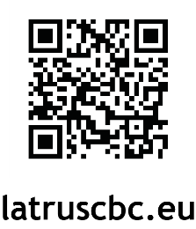
Purchase of equipment and materials will be supported by extensive trainings on various platforms for any involved target groups: from project partners study visits to volunteer muster-classes, from project round tables to participation in annual forum.
Contacts
Euregio “Pskov-Livonia” section Latvia
www.pskov-livonia.net

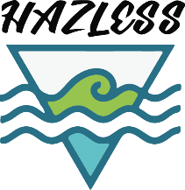
HAZardous chemicals in the eastern
Gulf of Finland — concentrations and impact assessment
Thematic objective
Environmental protection, climate change mitigation and adaptation.
Beneficiaries
- Tallinn University of Technology
- Institution of Russian Academy of Sciences Saint Petersburg Scientific Research Centre for Ecological Safety
- Zoological Institute of the Russian Academy of Sciences
Associate
Finnish Environment Institute
Budget  Total: 469.300,00 €  Programme co-finacing: 422.370,00 € | Duration  35 months  1.04.2019 — 28.02.2022
Summary
The Project focuses on adaptation and implementation of uniform biological indicators for assessment and control of environmental quality in the eastern part Gulf of Finland ( GoF ).
The development and harmonization of marine monitoring and environmental status assessment between countries sharing the same sub regions are essential.
The project is directly linked to the ongoing work in HELCOM and is the national (Estonian and Russian) and sub regional (GoF) contribution rather than duplication regard to the assessment of the impact of harmful substances.
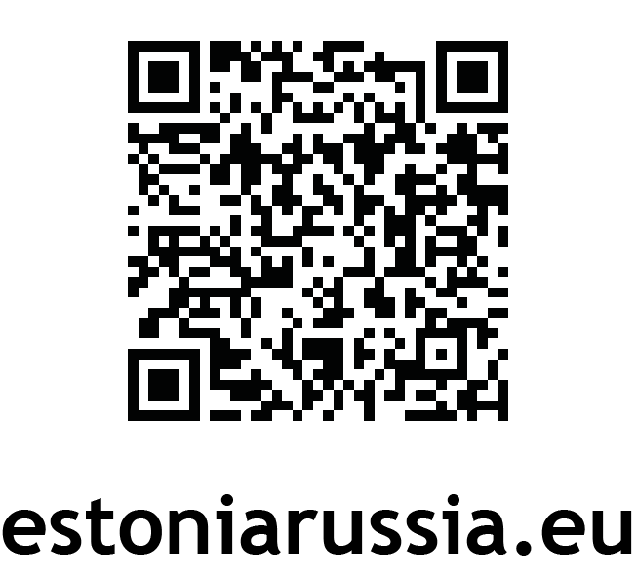
Within the course of 35 months beneficiaries will organize the exchange of information regarding the evaluation of pressures, joint attempts to fill in gaps regarding Good Environmental Status descriptors and boundaries.
Contacts
www.ecosafety-spb.ru

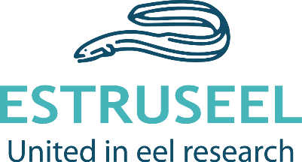
Restocking of European eel as a measure of recovery
of endangered species and preservation of natural diversity
Thematic objective
Environmental protection, climate change mitigation and adaptation.
Beneficiaries
- Centre for Limnology of the Estonian University of Life Science
- Federal State budget institution of sciences St. Petersburg Scientific Centre of the Russian Academy of Sciences
Associates
- Developers' Council of Lake Peipsi Fishing District
- Fisheries district of Lake Võrtsjärv.
Budget  Total: 361 856,00 €  Programme co-finacing: 325 670,40 € | Duration  36 months  01.03.2019 — 28.02.2022
Summary
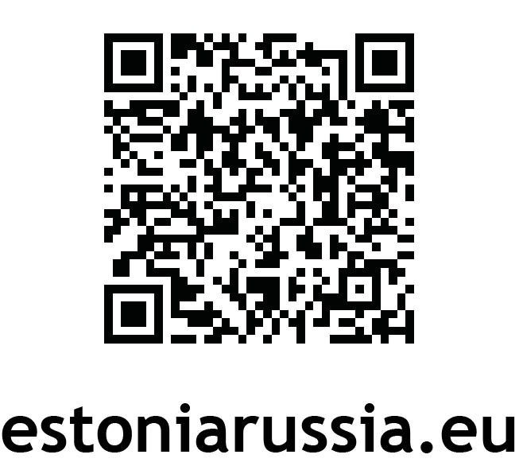
The Project will focus on stock assessment of European eel in the whole Narva River Basin District (RBD) to provide a valuable contribution to the European wide stock assessment of European eel.
Project approaches these challenges by using novel ways to estimate the abundance of eel on the waterbodies on both sides of the border.
The knowledge obtained in the frame of the three year action will make possible a better cross border management of the eel stock in future as well as more precise measurement of the restocking efficiency in Narva RBD.
This project would be the first time a joint assessment of eel stock between Estonian and Russian researchers.
Contacts
http://pk.emu.ee/en/

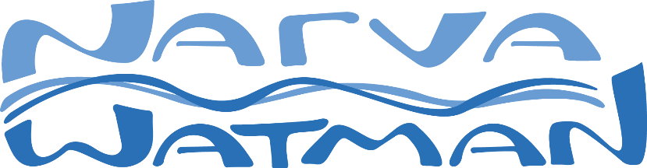
Water Managment of the Narva River: harmonizaion and sustention
Thematic objective
Environmental protection, climate change mitigation and adaptation.
Beneficiaries
- Tallinn University of Technology 260 030,00 EUR
- Federal State Budgetary Institution “State Hydrological Institute” 168 080,00 EUR
- State company "MINERAL" 137 740,00 EUR
Associates
- Narva City Government Department of City Maintenance
- Administration of municipal formation «City Ivangorod Kingisepp municipal district of Leningrad Region»
Budget  Total: 565 850,00 €  Programme co-finacing: 509 265,00 € | Duration  31 months  15.03.2019 — 02.11.2021
Summary
Implementation of the project will contribute to the overall good status of the Baltic Sea. As the result of the project:
- Narva river joint water assets management will be more effective
- Raised awareness and increased cooperation in the field of environmental protection
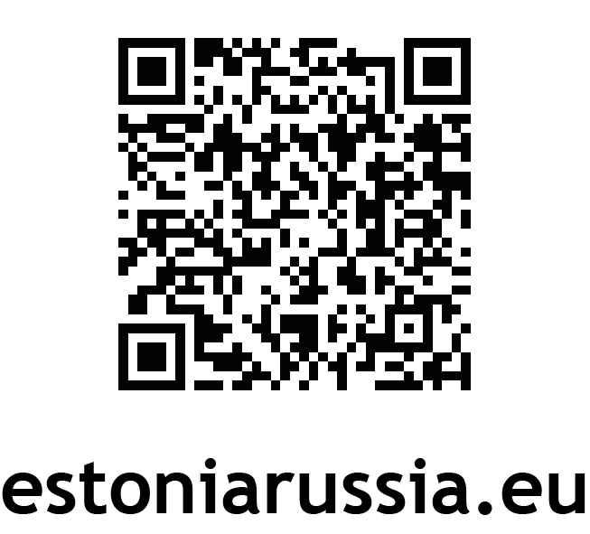
- The fulfillment by Russia and Estonia of International obligations (Est Rus JC, HELCOM) in achieving a healthy environment the Gulf of Finland of the Baltic Sea.
Contacts
www.narvawatman.com

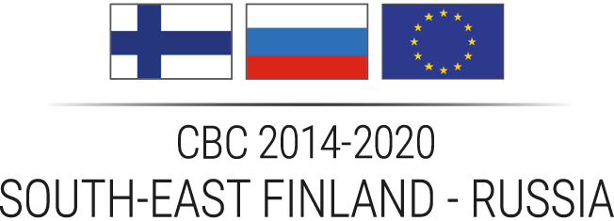
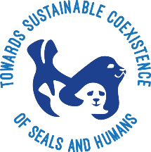
CoExist — Towards sustainable coexistence of seals and humans
Priority:
Attractive, clean environment and region
Beneficiaries
Lead Partner: University of Eastern Finland (Finland, North Karelia)
Partners:
- The Finnish Association for Nature Conservation, South Karelia division (Finland, South Karelia)
- ICPO “Biologists for nature conservation” (Russia, Saint Petersburg)
- Lappeenranta-Lahti University of Technology LUT (Finland, South Karelia)
Budget  Total: 866 823 €  Programme grant: 693 443 € | Duration  36 months  01.04.2019 — 31.03.2022
Summary
Ladoga lake in Russia and Saimaa lake in Finland are separated by the border, but at the same time they are strongly connected by their common preglacial past and very similar climate conditions. Both lakes are inhabited by endemic ringed seal (Pusa hispida) subspecies. These seals are unique, because they live in freshwater, but unfortunately both populations are considered endangered/vulnerable.
Collaboration of experts from Russia and Finland within the framework of the CoExist project is targeted at studying seals migrations and behavior to promote the coexistence of seals and humans, and to mitigate the seal-fisheries conflict. The threats of injuries and deaths when seals are bycaught by fishing gear are considered, as well as the ways to minimize losses of fisheries caused by seals’ predation and damaging gear and catch. Among the activities of the project are installation of camera traps, elaboration of the automated method for identification of individual ringed seals, creation of the database for both seal species, marking seals with satellite transmitters, and installing underwater vision cameras on fishing nets. Best practices of Finnish colleagues to protect catch and nets from seals will be used. Information about seals and best environment-friendly practices will be raised through various events and campaigns organised for the general public and in schools in Finland and Russia.
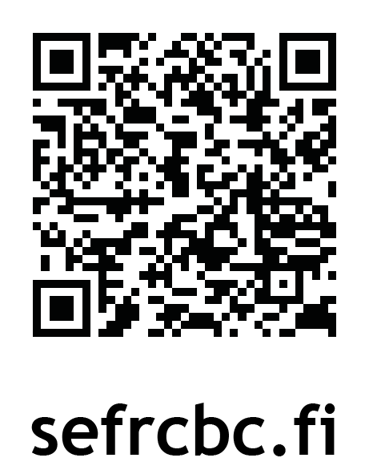
Contacts
www.uef.fi/en/web/coexist/1

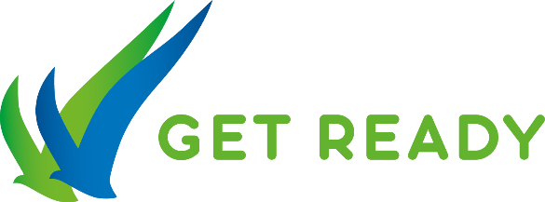
GET READY — Getting Ready for the Cross-Border Challenges:
Capacity Building in Sustainable Shore Use
Priority
Innovative, skilled and well-educated area
Beneficiaries
Lead Partner: Eco-Express-Service LLC (Saint Petersburg, Russia)
Partners:
- Federal State Budgetary Institution “State Hydrological Institute” (Saint Petersburg, Russia)
- Saint Petersburg State University (Saint Petersburg, Russia)
- University of Turku (Turku, Finland)
- South-Eastern University of Applied Sciences (XAMK) (Kymenlaakso, Finland)
- Finnish Environmental Institute (Uusima, Finland)
- Kotka Maritime Research Association (Kymenlaakso, Finland)
Budget  Total: 812 713 €  Programme grant: 650 171 € | Duration  36 months  01.05.2019 — 30.04.2022
Summary
All around the world, water ecosystems are in crisis, and many rivers, seas and lakes are already polluted or severely degraded as a result of reduced forest and catchment areas. The coastal zones are the places where the most productive ecosystems on Earth are located, and their vulnerability may cause threats to people and animals’ safety.
GET READY project’s objective is to build capacity in the field of environmental and professional education and training of sustainable use of shores and coastal management:
- raising professional level of coastal zone managers and related specialists to serve both technosphere and protected natural areas;
- creating educational programs and training courses for a wide range of specialists, youth and students, stakeholders and decision makers;
- developing infrastructure of the Russian-Finnish center for education, research and innovation in coastal zone management including distance learning capacities for continuous education and professional growth;
- introducing highly professional, scientific approach to shore use and coastal management in the GoF;
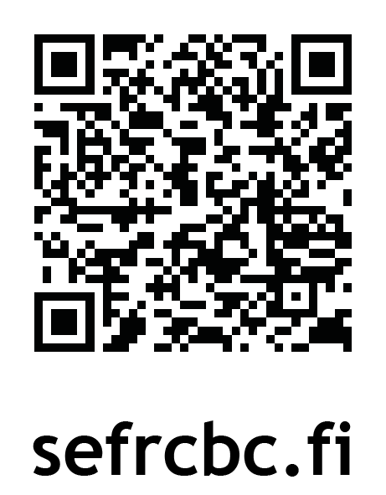
- contribution to the safe technosphere in the ports region based on innovative and environmentally friendly solutions.
Contacts
www.eco-getready.com

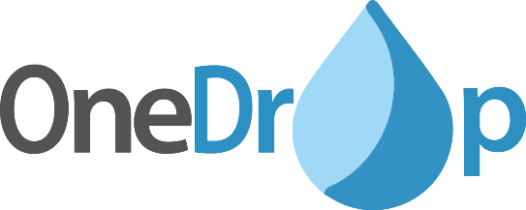
One Drop — A Novel Mobile Water Purification Plant
Priority
Attractive, clean environment and region
Beneficiaries
Lead Partner: Lappeenranta-Lahti University of Technology LUT (Finland, South Karelia)
Partners:
- Lappeenranta Free Zone Oy Ltd. (Finland, South Karelia)
- Saint Petersburg State University (Russia, Saint Petersburg)
- Peter the Great Saint Petersburg Polytechnic University (Russia, Saint Petersburg)
- OMEGA (Russia, Saint Petersburg)
Budget  Total: 1 184 140 €  Programme grant: 947 312 € | Duration  24 months  01.04.2019 — 31.03.2021
Summary
One Drop project is targeted at the research, design and development of an innovative mobile water purification plant.
The safety and efficiency of purification is ensured by ferrate – a powerful oxidizing agent, coagulant and flocculant, that can be applied for treatment of different types of wastewater: municipal wastewater, storm water, chemically contaminated wastewater from industrial enterprises, and toxic liquid waste.
Main activities include comprehensive research of water quality parameters and their treatment, comparison of novel and conventional methods and analysis, testing and validation of the wide range of research results.
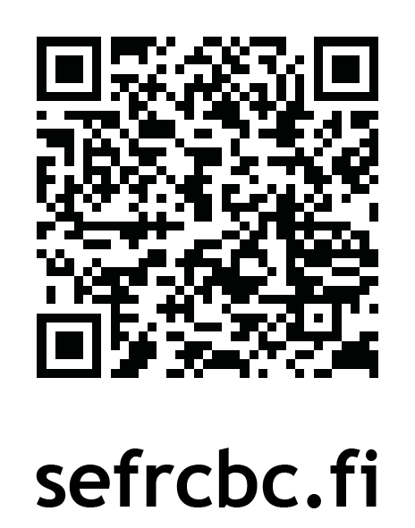
The project will result in an innovative technical and technological solutions for simultaneous production of sodium ferrate by membrane electrolysis method, and its application at place, ensuring effective and safe water purification exactly where it is most needed, including hard-to-reach locations, polluted sewage from vessels, wastewaters from industrial enterprises and toxic waste landfills. The project will also carry out a strategy to meet with the industrial actors and authorities and to develop and disseminate a Model Case on how to address One Drop customers and end-users, which have demand for new technologies, equipment and knowledge.
Contacts
www.lut.fi

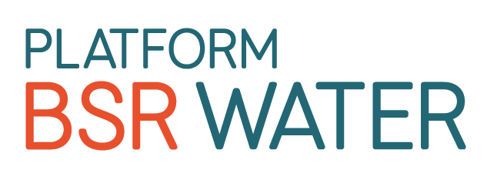
BSR WATER — Platform on Integrated Water Cooperation
Thematic objectives
Natural resources, Clear waters
Partners
10 partners from Finland, Russia, Germany, Estonia, Poland, Latvia
Leading partner: Union of the Baltic Cities, Sustainable Cities Commission c/o City of Turku
Partners from Russia:
- State Geological Unitary Company «Mineral» (SC Mineral)
- State Autonomous Institution of the Kaliningrad region "Environmental Center "ECAT-Kaliningrad"
Budget  Total: 1 133 440,40 €  Programme co-finacing: 889 945,47 € | Duration  30 months  10.2018 — 03.2021
Summary
More coordinated water management across borders can improve the Baltic Sea environment. The Baltic Smart Water Hub connects water experts from companies, associations, authorities, academia and NGOs. The platform BSR WATER fills the hub with knowledge on the management of smart sludge, storm and waste water, manure and energy efficiency. BSR Water builds on the Interreg Baltic Sea Region projects IWAMA, Manure Standards, Village Waters, BEST and Baltic Blue Growth as well as Interreg Central Baltic’s iWater, NutriTrade, Blastic and Waterchain and South Baltic’s RBR.
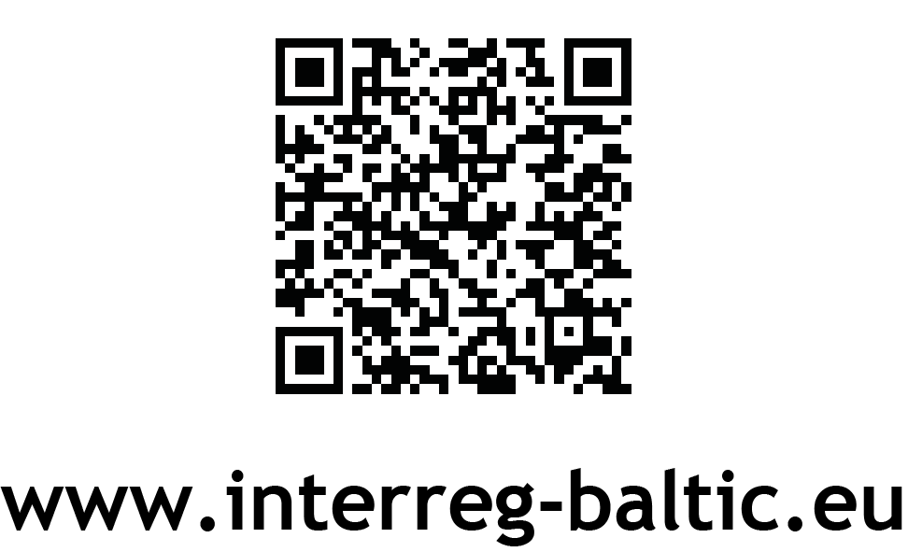
Contacts
www.bsrwater.eu
www.balticwaterhub.net

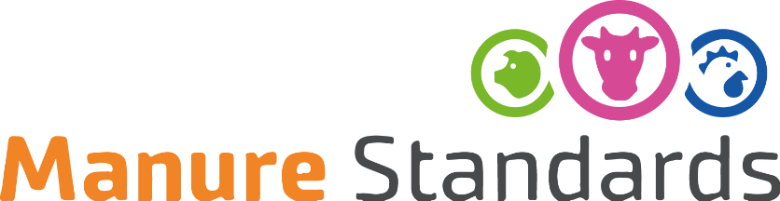
MANURE STANDARDS — Advanced manure standards
for sustainable nutrient management and reduced emissions
Thematic objectives
Natural resources, Clear waters
Partners
19 partners from Finland, Russia, Poland, Sweden, Lithuania, Estonia, Germany, Denmark, Latvia.
Leading partner: Natural Resources Institute Finland Luke
Partners from Russia:
- Federal State Budgetary Scientic Instition , Federal Scientific Agroengineering Center VIM IEEP-branch of FSBSI FSAC VIM
- Interregional Public Organization «Society for Assistance of Sustainable Rural Development»
- State budgetary vocational educational institution of the Pskov region «Pskov agrotechnical college»
Budget  Total: 2 865 116,18 €  Programme co-finacing: 2 274 437,09 € | Duration  27 months  10.2017 — 12.2019
Summary
Agriculture releases large amounts of nutrients into the Baltic Sea, with a significant amount of emissions from animal manure. In this project, policy makers, authorities, advisors, farmers and researchers create, test and implement tools to determine manure standards for farming practices and policy instruments. The new manure standards are to improve nutrient recycling and reduce nutrient inflow in the Baltic Sea.
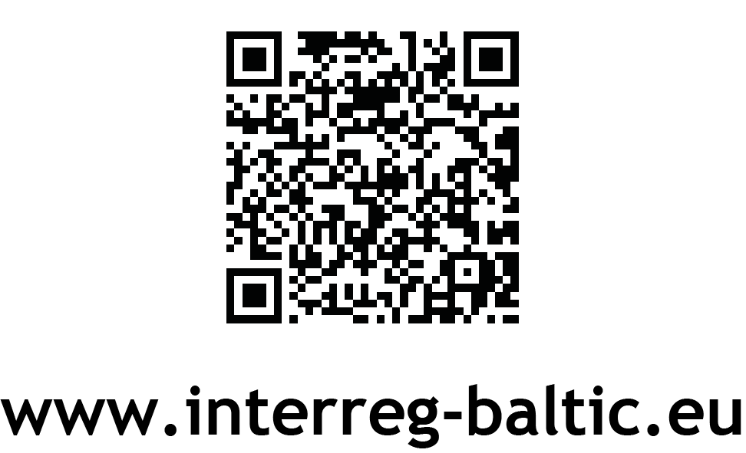
Contacts
www.luke.fi/manurestandards

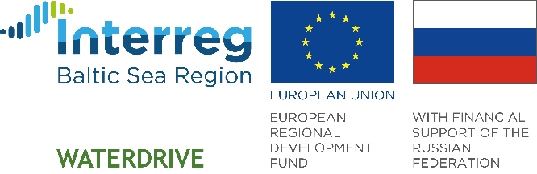

WATERDRIVE — Water driven rural development in the Baltic Sea Region
Thematic objectives
Natural resources, Clear waters
Partners
22 partners from Sweden, Russia, Lithuania, Finland, Estonia, Latvia, Poland, Germany, Denmark.
Leading partner: Swedish University of Agricultural Sciences
Partners from Russia:
- Northwest Research Institute of Agricultural Economics and Organisation (NWRIAEO)
- Institute for Engineering and Environmental Problems in Agricultural Production – branch of Federal State Budgetary Scientific Institution “Federal Scientific Agroengineering Center VIM” (IEEP)
- Administration of Guryevsk city district
Budget  Total: 3 171 587,00 €  Programme co-finacing: 2 524 858,95 € | Duration  30 months  01.2019 — 06.2021
Summary
Targets for water quality set by national and international legislation such as the Water Framework Directive have not been met yet in many regions around the Baltic Sea. There seems to be a lack of capacity among local authorities to reach these targets and at the same time to develop competitive rural businesses.
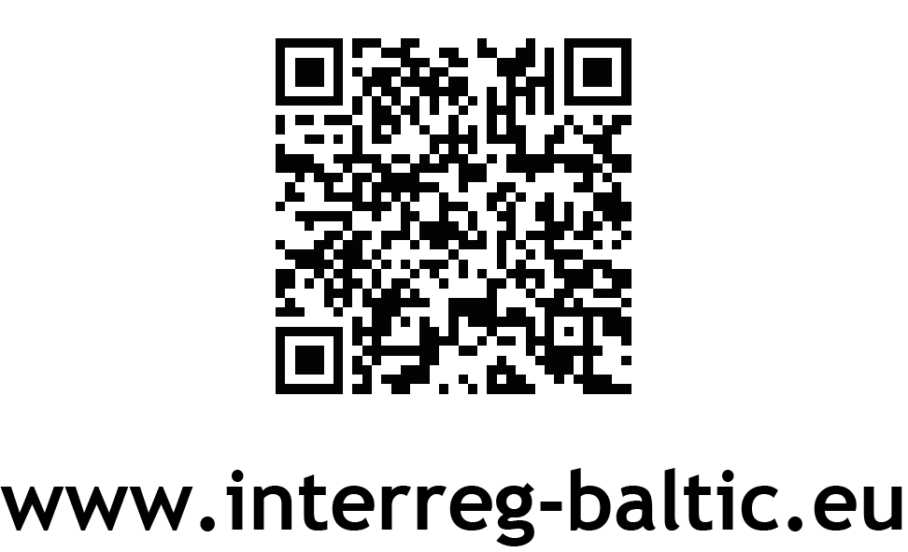
The WATERDRIVE project enhances local implementation practices for responsible water management by providing tools and training for about 20 rural communities.
Contacts
www.infowaterdrive.com

Notes

_________________________________________________________________________________________________________________________________________________________________________________________________________________________________________________________________________________________________________________________________________________________________________________________________________________________________________________________________________________________________________________________________________________________________________________________________________________________________________________________________________________________________________________________________________________________________________________________________________________________________________________________________________________________________________________________________________________________________________________________________________________________________________________________________________________________________________________________________________________________________
___________________________________________________________

_________________________________________________________________________________________________________________________________________________________________________________________________________________________________________________________________________________________________________________________________________________________________________________________________________________________________________________________________________________________________________________________________________________________________________________________________________________________________________________________________________________________________________________________________________________________________________________________________________________________________________________________________________________________________________________________________________________________________________________________________________________________________________________________________________________________________________________________________________________________________

