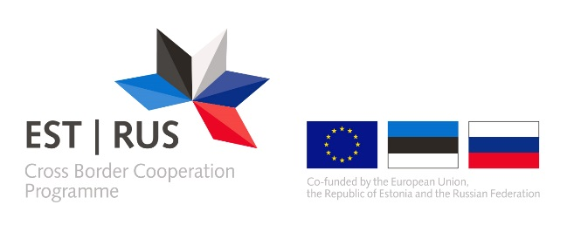 ANNEX 5

APPLICANTS AND/OR PARTNERS DECLARATION OF MEETING THE CRITERIA OF A MICRO, SMALL OR MEDIUM SIZED (SME) ENTERPRISE
The applicant and/or partner declares that according to the Commission Recommendation 2003/361/EC and Annex I of the Commission Regulation (EU) No 651/2014 it is considered to be a micro, small or medium sized enterprise.

The applicant and/or partner declares that its financial thresholds and number of employees together with its partner and linked enterprises is as stated below:
Staff headcount (in annual work units, AWU) | Annual turnover | Annual balance sheet

Commission Recommendation of 6 May 2003 concerning the definition of micro, small and medium-sized enterprises( OJ L 124, 20.5.2003, p. 36), http://eur-lex.europa.eu/legal-content/EN/TXT/?uri=uriserv:OJ.L_.2003.124.01.0036.01.ENG&toc=OJ:L:2003:124:TOC
Commission Regulation (EU) No 651/2014 of 17 June 2014 declaring certain categories of aid compatible with the internal market in application of Articles 107 and 108 of the Treaty Text with EEA relevance (OJ L 187, 26.6.2014, p. 1–78), http://eur-lex.europa.eu/legal-content/EN/TXT/?qid=1457175370736&uri=CELEX:32014R0651
The data is calculated on an annual basis and is related to the last approved accounting period

