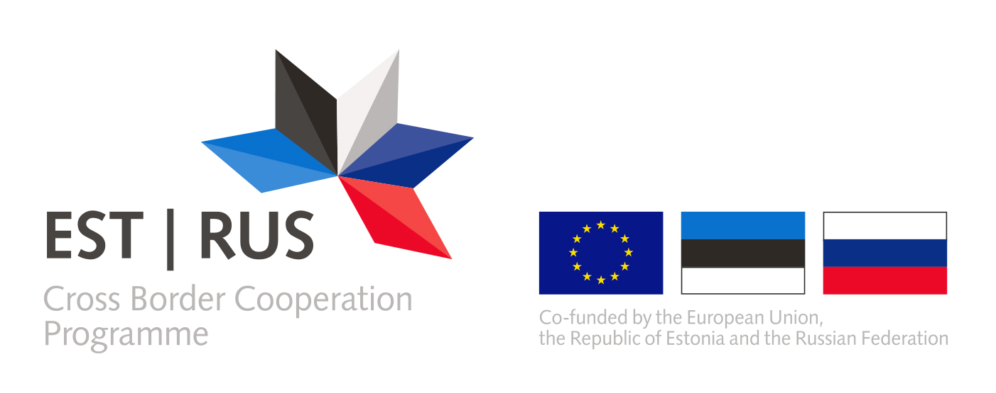
ANNEX 15

<To be filled on the official letterhead of the organisation>
<Is to be filled by all partner organizations participating in the project, including the Applicant>
Delete the grey highlighted lines after filling!
EVIDENCE OF OWNERSHIP OR ACCESS TO THE LAND
Title of the project
Name of the legal entity applying for funding as a partner in original and English languages
The applicant/ partner, <insert the title of the Applicant/partner organization>represented by the undersigned, being the authorised signatory of the applicant/partner, hereby provides following evidence (s) of ownership or access to the land there the project <name of the project> infrastructure component will take place:

Name and position of the signatory
Location
Date of signature
Signature and stamp

